Horsetaming Wheel Bicycle 9.000 b.c 4500 b.c 1839 Humans(Arabia) Humans(Mesopotamia) Kirkpatrick Macmillan Horses were tamed and The wheel made a significant Bicycle was moved by and used for transport change in mobility and human force, and they to work in the field humanity meant that animals weren’t W so needed for transport

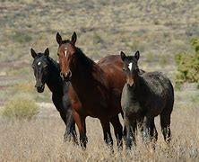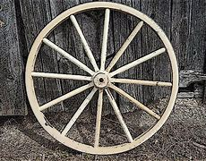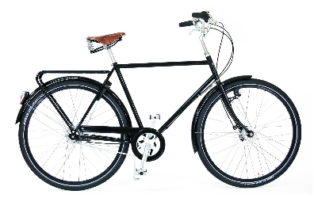

Car Steam machine(1712,1765) 1886 Steamboat(1807) Robert Fulton Karl BenzS Steam railway(1825)George Stephenson It became the familiar transport and It helped for transporting people and people could leave outside the cities. products faster, but the steamboat was It also stablished the new middle class. across countries, and the railway, inside ountry a country

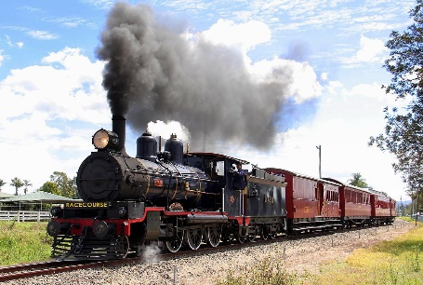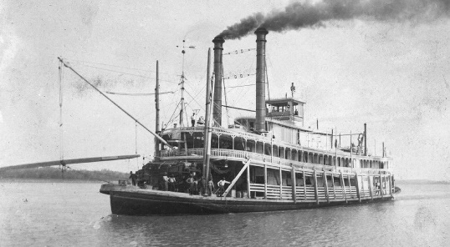

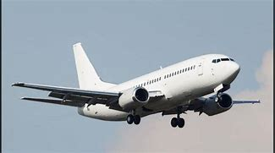Plane Electric vehicles 1890 1980 Clément Ader Electric vehicles were made to People could go to other far places replace fuel cars due to the a lot faster, specially globally. contamination and to not It isn’t tied to land or sea, it has no boundary. Damage the environment so m much.

